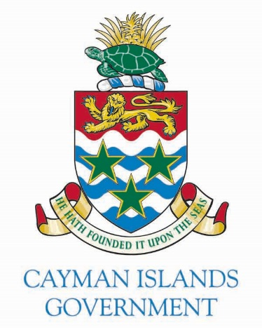

FOR IMMEDIATE RELEASE
Date: 21 September 2022
Issued by: Governor’s Office
Contact: Simone.Eade@fcdo.gov.uk

APPOINTMENT OF THE NEW CHIEF JUSTICE

The Judicial and Legal Services Commission (JLSC) recently undertook a formal recruitment exercise for the post of Chief Justice. As the Head of the Judiciary, the Chief Justice has responsibility for the efficient administration of justice in the Cayman Islands.
Further to this recruitment exercise by the JLSC, His Excellency The Governor, Martyn Roper, OBE has appointed Justice Margaret Ramsay-Hale as the Chief Justice effective 26th October 2022.
His Excellency said: “I am delighted to appoint Justice Ramsay-Hale to this very important role within the Judiciary. Justice Ramsay-Hale, who is Caymanian, brings extensive legal knowledge and significant leadership and management experience, including as a former Chief Justice in the Turks and Caicos Islands. Justice Ramsay-Hale impressed the JLSC with her vision, passion and commitment to strengthening our judicial system and rule of law in line with the Cayman Constitution.

“Justice Ramsay-Hale will build on the successful legacy of outgoing Chief Justice, Sir Anthony Smellie, KCMG, KC who has provided strong leadership and services to law and justice in the Cayman Islands and the wider Caribbean over the last 30 years as a judge, with nearly 25 years as Chief Justice. I am grateful to Sir Anthony for his long years of dedicated service, which is greatly appreciated by the community. In recognition of his outstanding contribution, Sir Anthony was awarded a Knighthood in Her Late Majesty The Queen’s Birthday Honours.
“It is a signal of strong confidence in the Judiciary in the Cayman Islands that the JLSC recommended an appointment from the bench in Cayman. A high quality and fully independent judiciary is one of major strengths of our jurisdiction supporting the rule of law and our prosperity."

Follow HE The Governor on social media:
Facebook @govcaymanislands @martynroper

